**Social Media Marketing**

**Week 2: Content Creation & Audience**

**Engagement.**

**Submitted By: Iqra Tariq**

**Objective: Learn the art of content creation and how to engage different audiences.**

**Task 1:** Design **5 sample social media posts**(image/text-based) using Canva or any tool.

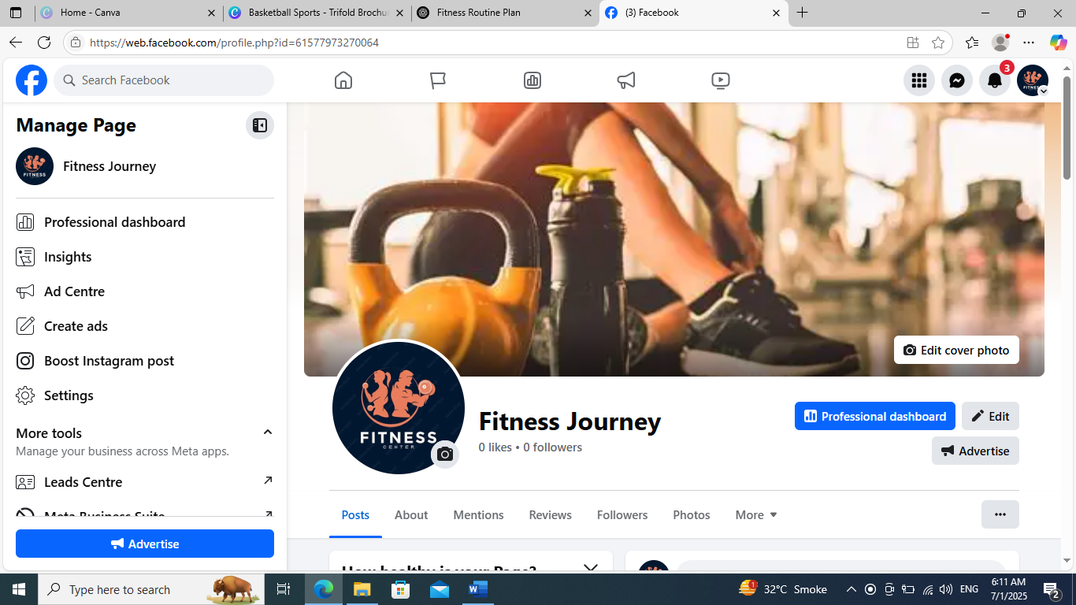

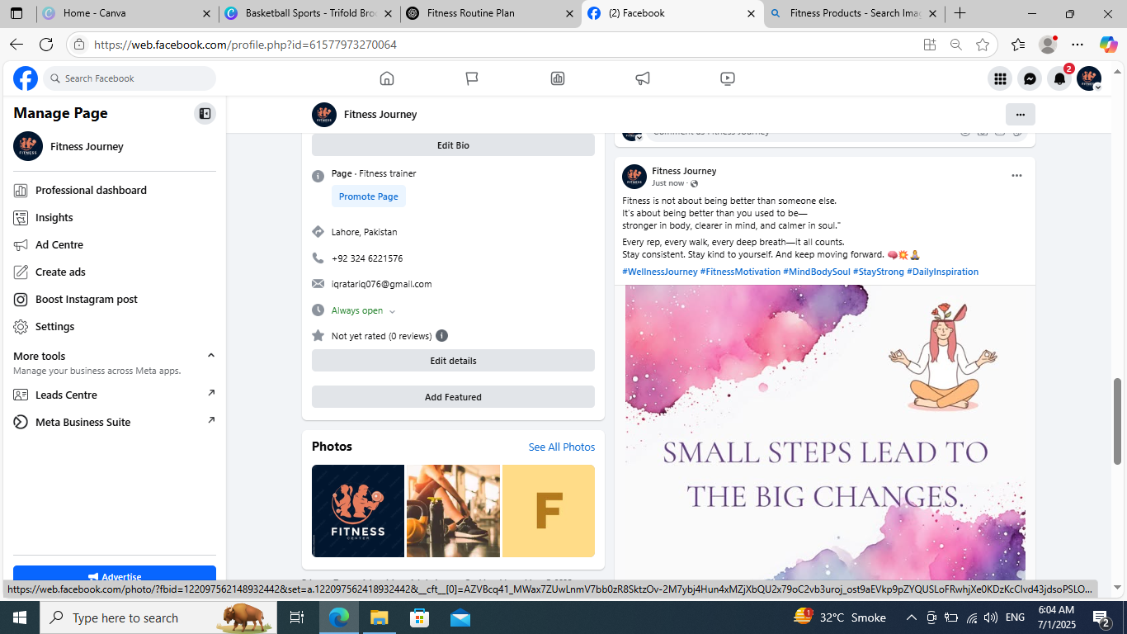

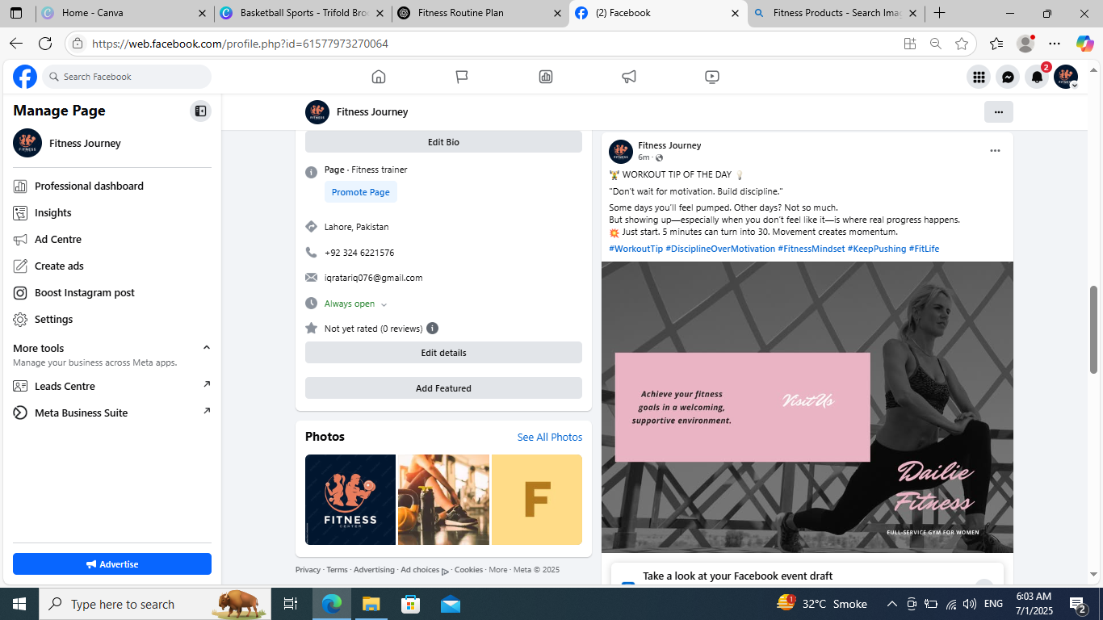

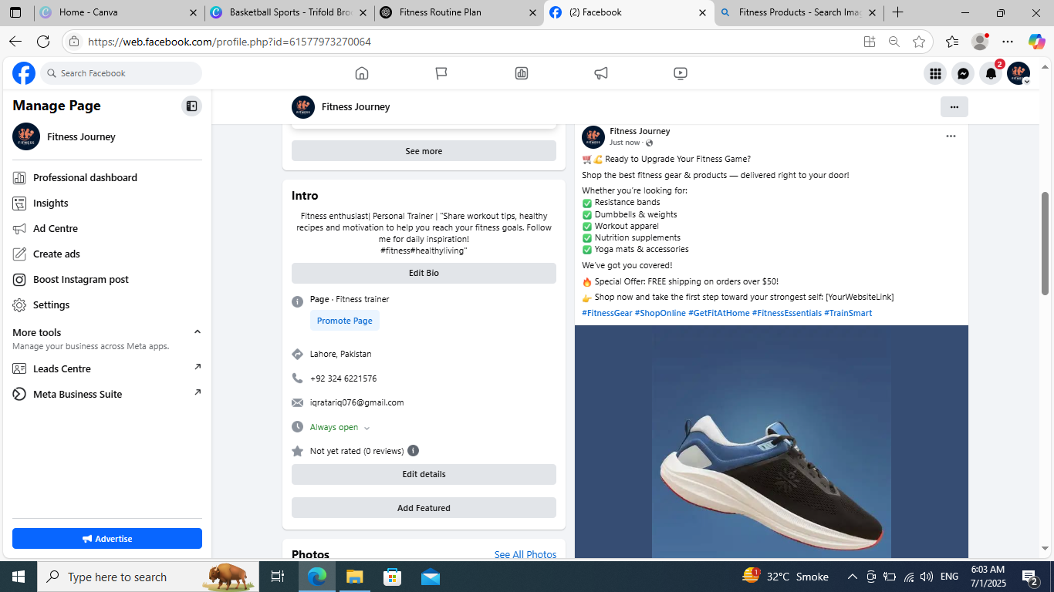

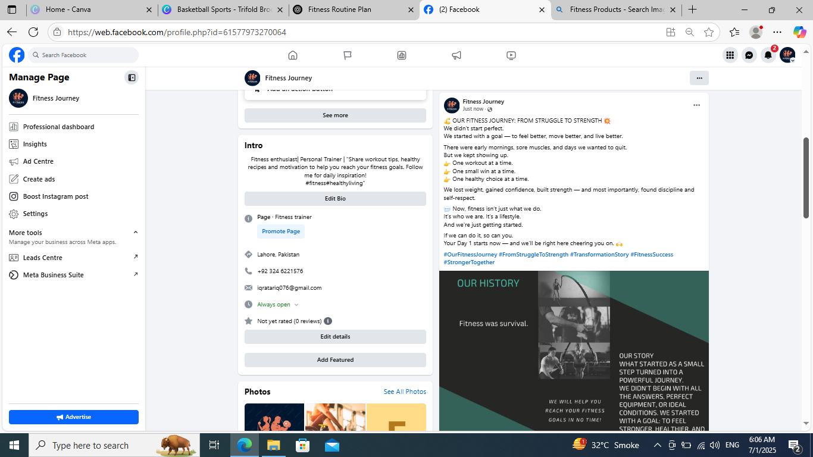

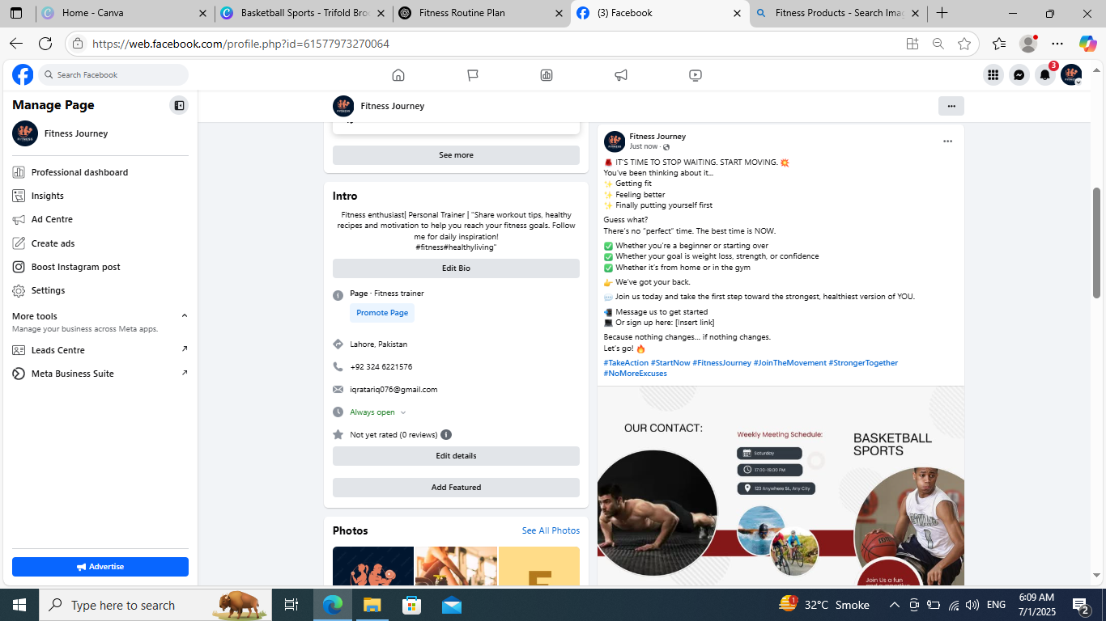

**Task 2:** Write **3 captions for product promotion** and **2 for audience engagement** (questions, polls, tips).

**Product Promotion:**

👟 **Train Hard. Move Smart.**  
Step into comfort, power, and performance with our top-tier fitness shoes — built for every squat, sprint, and stretch.

✅ Non-slip grip  
✅ Breathable comfort  
✅ Maximum support for every move

Your fitness deserves the right foundation.  
💥 Lace up and level up.

#FitnessGear #TrainingShoes #MoveWithPurpose #FitFeetStrongBody #StepUpYourGame

🏋️‍♂️ **Gear Up. Get Results.**

From home workouts to hardcore sessions — the right equipment makes all the difference.  
🔥 Resistance bands  
🔥 Dumbbells  
🔥 Kettlebells  
🔥 Yoga mats & more

Train smarter. Sweat harder. Recover faster.  
💪 Everything you need, delivered to your door.

🛒 Shop now & upgrade your fitness setup.

#FitnessEquipment #TrainAtHome #GearUp #StrongerEveryday #HomeGymEssentials #WorkoutReady

3.🪑💪 **Power. Comfort. Convenience.**  
Meet your new workout partner: the **Folding Fitness Bench** — strong enough for serious training, compact enough for any space.

✅ Adjustable for multiple angles  
✅ Supports strength training & core work  
✅ Folds flat for easy storage  
✅ Perfect for home gyms & small spaces

Why go to the gym when the gym can come to you?  
📦 Order yours today and start training smarter:

#FoldingFitnessBench #HomeGymGear #StrengthStartsHere #CompactButPowerful #TrainAnywhere

**Audience engagement:**

1.

💬 **QUESTION TIME!** 🏋️‍♂️💥  
Let’s talk FITNESS!

What’s harder for you right now?  
👇 Drop your answer in the comments:

A) Staying consistent  
B) Eating clean  
C) Finding time to work out  
D) Getting motivated

There’s no wrong answer — just real talk! 💯  
We’re all in this together 💪 Let’s support each other and grow stronger every day.

Tag a workout buddy & let’s get the conversation going! 🔥

#FitnessCommunity #RealTalkFitness #StrongerTogether #FitLife #WorkoutStruggles #EngageAndGrow

2.💡 **FITNESS TIP FRIDAY!** 🏋️‍♀️

**Tip of the day:**  
👉 "Progress is built on consistency, not intensity. Even a 20-minute workout beats doing nothing!"

Now we want to hear from YOU!  
👇 Drop your favorite fitness tip in the comments — let’s share the knowledge and help each other grow stronger!

📣 Bonus: We’ll feature the best tips in our next post 👀💬

#FitnessTips #CommunityStrong #WorkoutWisdom #FitFamSupport #ConsistencyIsKey #TipOfTheDay

**Task 3:** Research and list **5 content ideas for Reels/Shorts/TikTok** in your niche.

**🎥 1. “Before & After Workout Energy”**

* **Clip 1:** Tired face, yawning, no motivation
* **Clip 2:** Post-workout glow, sweating, high-energy
* 🎵 Use trending audio for contrast
* 💬 Caption: *“Never regret a workout. The hardest part is starting.”*

**🎥 2. “1 Dumbbell, 5 Killer Moves”**

* Quick demo of 5 compound exercises using only one dumbbell (e.g., goblet squat, renegade row, shoulder press, etc.)
* Use jump cuts and energetic music
* 💬 Caption: *“No excuses. Just results. One dumbbell is all you need!”*

**🎥 3. “What People Think vs. Reality at the Gym”**

* Split screen or back-and-forth shots
* Example:
  + What people think: Perfect form, flawless outfit
  + Reality: Sweating, struggling, making faces
* 💬 Caption: *“We all start somewhere. Keep going 💪”*

**🎥 4. “Quick Fix: Correcting Common Mistakes”**

* Show incorrect vs. correct form in 10–15 seconds (e.g., squats, push-ups, planks)
* Add arrows, text, or slow-mo. for clarity
* 💬 Caption: *“Fix your form = better gains + fewer injuries!”*

**🎥 5. “Day in the Life: Fitness Edition”**

* Morning routine, meals, workouts, hydration, recovery
* Keep it fast-paced and aesthetic with trending sounds
* 💬 Caption: *“Fitness is a lifestyle, not just a workout.”*

**Task 4:** Create a **7-day content calendar** for your selected niche.

🗓️ **7-Day Fitness Content Calendar**

|  |  |  |  |  |
| --- | --- | --- | --- | --- |
| **Day** | **Theme** | **Content idea** | **Platform tips** | **CTA** |
| Day 1 (Monday) | Motivation Monday | Post a before/after story or client transformation with a motivational quote | Instagram Post + Story + Reels | “Drop a 🔥 if you're starting your week strong!” |
| Day 2 (Tuesday) | Training Tip Tuesday | Share 3 common form mistakes for squats + how to fix them (carousel or reel) | IG Carousel or Reel, TikTok | “Save this for your next leg day!” |
| Day 3 (Wednesday) | Workout Wednesday | 20-minute full-body HIIT workout (video or PDF download) | YouTube Shorts + IG Reels + Email | “Tag a workout buddy 💪” |
| Day 4 (Thursday) | Throwback Thursday | Share your personal fitness journey from 1 year ago to now | Instagram Post + Caption Story | “Where were YOU a year ago?” |
| Day 5 (Friday) | Food/FAQ Friday | Share a healthy post-workout meal or answer a common fitness question | IG Reel + Story Poll + Twitter Thread | “Want more meal ideas like this? Comment YES!” |
| Day 6 (Saturday) | Sweat Saturday | Go live for a 30-min bodyweight workout OR post a challenge (e.g., 100 squats/day) | IG Live + TikTok + Email Reminder | “Join me LIVE! 🔴” |
| Day 7 (Sunday) | Self-Care Sunday | Talk about rest, recovery, and mental health + foam rolling/stretching routine | IG Reels or Stories + Blog/Email | “What's your rest day routine? 🧘” |

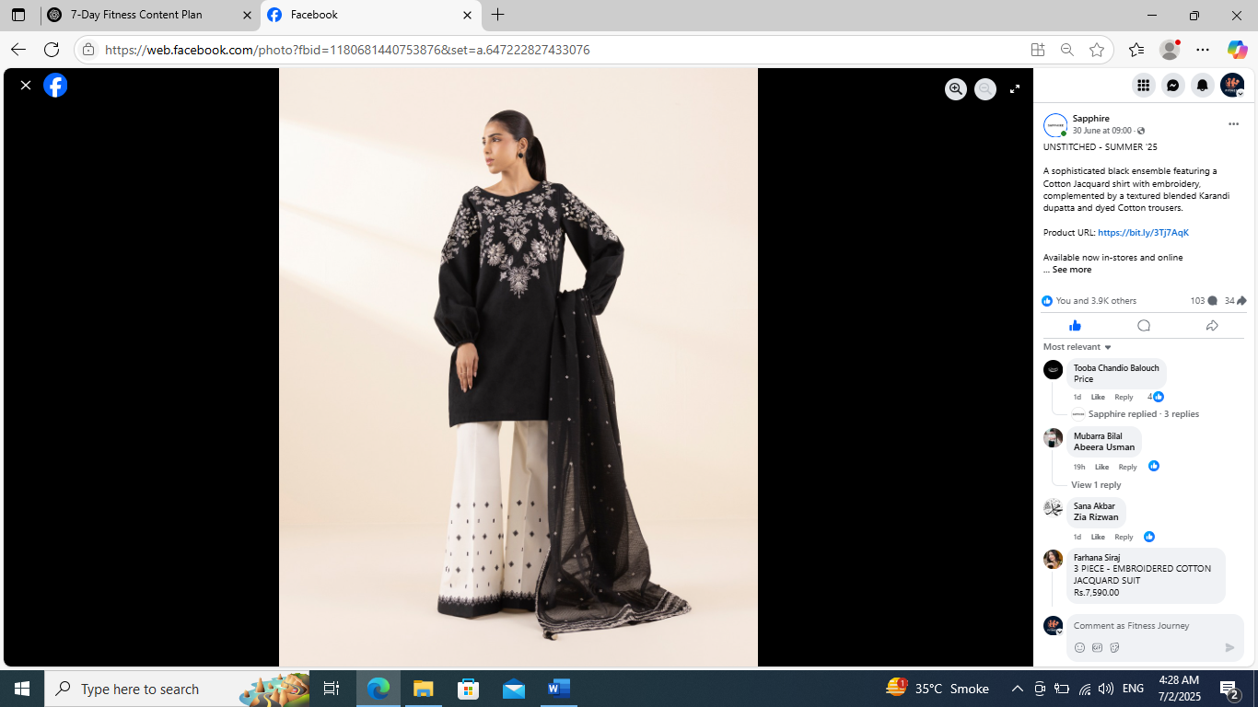**Task 5:** Analyze **3 popular posts** from any brand page and note what made them engaging (content type, caption, hashtag).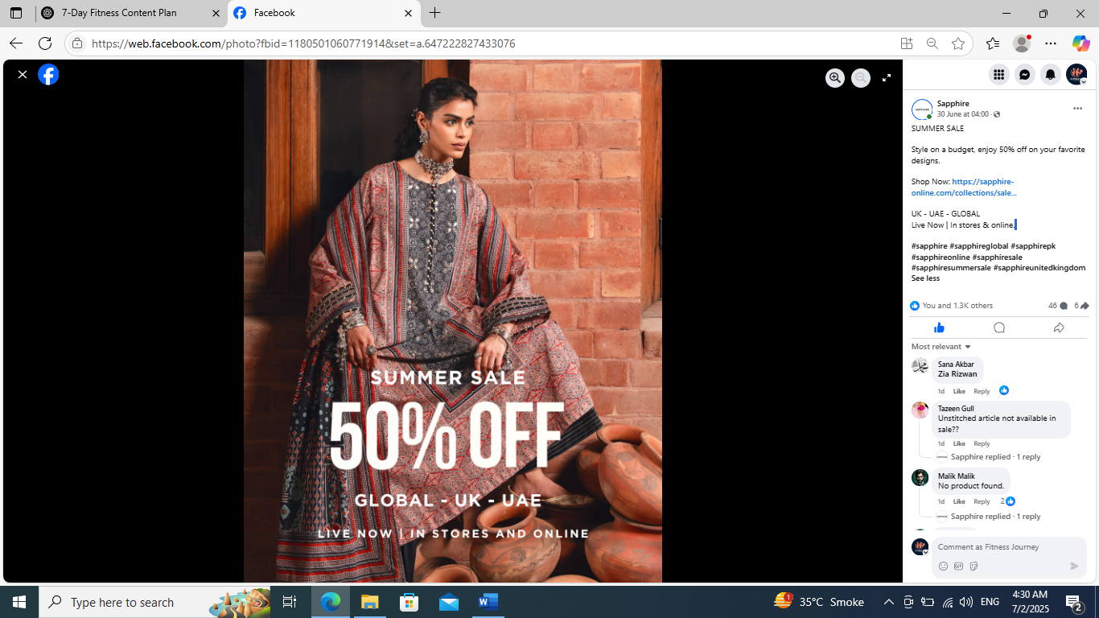

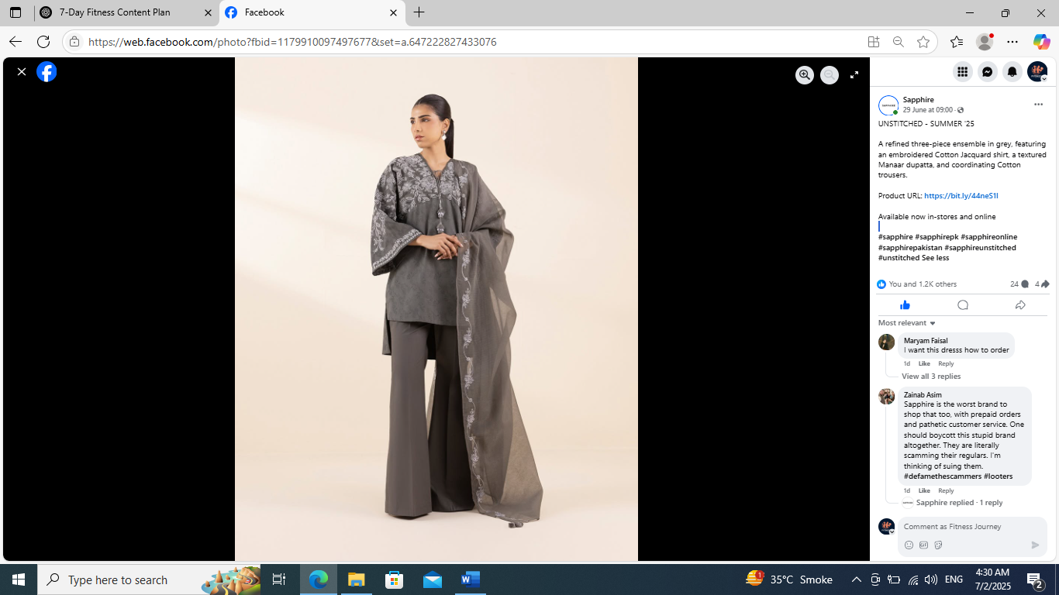

I analyze that in all of 3 posts, the most engaging is their content type.